A Multi-Player, Multi-Platform, and Protocol Independent Framework:

Developed for Games and Simple Networked Applications

Michael Richardson

Utah Valley University

Abstract

This project is to build multi-player and multi-platform space-themed games with a modular architecture, variety of supported network protocols, and elements of gameplay for both entertainment and education. My portion of the project is developing the framework in which these games will run. I defined requirements, designed, built and tested a server and game engine to run in Python on a Linux machine and clients to run on a desktop or on the web.

*Keywords: multi-platform, multi-player, games, protocol*

Project Report

Contents

List of Deliverables 11

Project Overview and Goals 12

License Information 14

Project Schedule 15

Detailed Description of Problem Being Solved 16

Research Methodology and Findings 17

Requirements Summary 17

Modular Architecture 17

Architecture Overview 17

Platform Independence 17

The Server 17

Game Engines 17

Clients 18

Network Protocol Independence 18

Network Protocol Overview 18

Ubiquitous data format (JSON) 18

The Server communicates over multiple network protocols 18

Game Engines communicate over multiple network protocols 18

Clients communicate over multiple network protocols 19

Abstraction of Networking and Data Storage 19

The Server 19

Game Engines 19

Clients 19

Communication Process 19

Excellent Documentation 19

Motivation 19

Deliverables 20

Potential Games 20

Chess 20

Risk 20

StarCraft 20

SpaceTrader 20

Game Prototype 20

Prototype Details 20

Prototype Objects 21

Overview of Design 22

Network Architecture 22

Client Module Logic 23

Server Module Logic 24

Game Engine Module Logic 25

Client-Server Dialogue 26

Client-Game Engine Dialogue 27

Client-Server Dialogue 28

Discussion of Implementation 29

The Server 29

Game Engine 29

Desktop Client 29

Web Client 29

Prototype 29

Problems Encountered 30

The Server 30

Game Engine 30

Desktop Client 30

Web Client 31

Prototype 31

What was Learned? 32

The Server 32

Game Engine 32

Desktop Client 32

Web Client 32

Future Work 33

The Server 33

Python Game Engine 33

Networking 33

Game Engines 33

Python Game Engine 33

Networking 33

C# Game Engine 33

Java Game Engine 33

NodeJS Game Engine 33

Clients 33

HTTP Desktop Client 33

HTTP Web Client 33

Android Native Client 33

IOS Native Client 33

Windows Modern Native Client 34

SMS Client 34

Game View 34

Offline app? 34

Prototype Games 34

Text-based 34

2D tile based game 34

Space Trader 34

Appendix I – Original Proposal 35

Project Proposal 36

Abstract 36

Detailed Description 36

Applicable Tools, Platforms and Standards 37

Licensing 38

Proposed Deliverables 38

Project Schedule 38

Project Details 39

Appendix II – Work Log 40

January 6, 2014 44

Space Trader 44

Overview 44

Features 44

Sid Meier's Pirates! 45

Endless Space 46

January 7, 2014 46

Dwarf Fortress 47

Meeting with Professor Durney 47

January 8, 2014 47

January 9, 2014 47

January 14, 2014 47

January 15, 2014 47

January 20, 2014 47

January 27, 2014 47

February 5, 2014 47

February 7, 2014 47

February 8, 2014 48

February 12, 2014 48

February 14, 2014 48

February 19, 2014 48

February 20, 2014 48

February 27, 2014 48

March 6, 2014 48

March 13, 2014 48

March 16, 2014 49

March 17, 2014 49

March 20, 2014 49

March 24, 2014 49

March 31, 2014 49

April 4, 2014 49

April 5, 2014 49

April 8, 2014 49

April 14, 2014 49

April 20, 2014 49

April 21, 2014 49

April 22, 2014 49

April 24, 2014 49

April 25, 2014 50

April 26, 2014 50

April 28, 2014 50

April 29, 2014 50

April 30, 2014 50

May 1, 2014 50

Appendix III – Requirements 51

Requirements Summary 54

Modular Architecture 54

Architecture Overview 54

The Server Module 55

Game Engine Modules 56

Client Modules 57

Platform Independence 57

The Server 57

Game Engines 57

Clients 57

Responsive Web Design 58

Game Engine – Server Dialogue 58

Client – Server Dialogue 59

Client – Game Engine Dialogue 60

Network Protocol Independence 61

Network Protocol Overview 61

Ubiquitous data format (JSON) 61

The Server communicates over multiple network protocols 61

Game Engines communicate over multiple network protocols 61

Clients communicate over multiple network protocols 61

Abstraction of Networking and Data Storage 61

The Server 61

Game Engines 61

Clients 62

Communication Process 62

Excellent Documentation 62

Motivation 62

Deliverables 62

Potential Games 62

Chess 62

Risk 63

StarCraft 63

SpaceTrader 63

Game Prototype 63

Prototype Details 63

Prototype Objects 63

Appendix IV – JSON Messages 65

Server – Game Engine 68

Server Session Inform (Server to Game Engine) 68

Get Session Inform (Game Engine to Server) 68

Game Inform (Game Engine to Server) 68

Get Game Inform (Server to Game Engine) 68

Success (Game Engine to Server) 69

Error (Game Engine to Server) 69

Success (Server to Game Engine) 69

Error (Server to Game Engine) 69

Client – Game Engine 70

Game Session Request (Client to Game Engine) 70

Game Session (Game Engine to Client) 70

Game Chat Message (Client to Game Engine | Game Engine to Clients) 70

Get Game Chat Message (Client to Game Engine) 70

Get Game Update (Client to Game Engine) 70

Game Update (Game Engine to Client) 71

Game Command (Client to Game Engine) 71

Terminate Game (Client to Game Engine) 71

Success (Game Engine to Client and Server) 71

Fail (Game Engine to Client and Server) 71

Error (Game Engine to Client and Server) 72

Client – Server 73

Server Session Request (Client to Server) 73

Server Session (Server to Client) 73

Server Chat Message (Client to Server | Server to Clients) 73

Get Server Chat Message (Client to Server) 73

Get Game List (Client to Server) 73

Game List (Server to Client) 74

Terminate Session (Client to Server) 74

Success (Server to Client and Game Engine) 74

Fail (Server to Client and Game Engine) 74

Error (Server to Client and Game Engine) 75

Appendix V – JSON Objects 76

Server 78

Game Engines 78

Game Engine 78

HTTP Clients 78

HTTP Client 78

Sever Sessions 78

Server Session 78

Users 78

User 78

Game Information List 78

Game Information 79

Server Chat Messages 80

Server Chat Message 81

Game Engine 82

HTTP Clients 82

HTTP Client 82

Sever Sessions 82

Server Session 82

Game Sessions 82

Game Session 82

Players 82

Player 83

Game 83

Game Updates 83

Game Update 83

Game Information 83

Game Chat Messages 84

Game Chat Message 84

Client 85

Game Command 85

Appendix VI – Presentation 86

# List of Deliverables

1. Project Source Code (GIT Repository)

2. Communication Libraries and Documentation (Finished and Polished)

3. Multi-platform game (Prototype)

4. Web Client (Prototype)

5. Desktop Client (Prototype)

6. Server (Prototype)

7. Game Engine (Prototype)

8. Final Project Report

9. Final Project Presentation

# Project Overview and Goals

This is a long-term project spanning multiple semesters with a modular architecture so students can work on modules independently or as part of a research group. The game will have a space theme and will incorporate aspects of role-playing, strategy, and 4x games (explore, expand, exploit, and exterminate).

My portion of the project is to define requirements, design, build and test libraries for clients, game engines, and a server with a database for players, characters, and world (setting) information. The server and game engine are written in python and support HTTP traffic and web socket traffic. The database used for the server and game engine stores data as JSON objects in MongoDB. The project requires a central server and game engine prototype with logic for database, communication and game functionality.

The communication logic is built to support websocket connections, HTTP request/response communication, JSON traffic and dialogues needed for the protocol. The protocol includes definitions of the types of data and their properties. Network connections for both HTTP and real-time websocket traffic. Players may use a native desktop application, or desktop and mobile browsers.

The project requires a desktop client for Windows and a web (browser) client. The desktop client is built using Visual Studio 2012 to build a WPF application. The browser client is built to be compatible with all major desktop browsers (Chrome, Safari, Firefox and Internet Explorer) and modern phone browsers.

The early prototype of the space-themed game allows players to move around a map, collect items, achieve some victory condition and communicate real-time with other players. The objective of the server and client is to demonstrate the functionality of the libraries and protocol. Git provides version control for all the project source code and documentation. The Source code is released as open source under the Apache License.

# License Information

The source code is licensed under the Apache License, Version 2.0 as follows:

Copyright 2014 Michael Richardson

Licensed under the Apache License, Version 2.0 (the "License");

you may not use this file except in compliance with the License.

You may obtain a copy of the License at

http://www.apache.org/licenses/LICENSE-2.0

Unless required by applicable law or agreed to in writing, software

distributed under the License is distributed on an "AS IS" BASIS,

WITHOUT WARRANTIES OR CONDITIONS OF ANY KIND, either express or implied.

See the License for the specific language governing permissions and

limitations under the License.

# Project Schedule

January 6 – Gather and define requirements

January 13 – Gather and define requirements

January 20 – Design game and API

January 27 – Build Server communication library

February 3 – Build Server communication library

February 10 – Build Game Engine communication library

February 17 – Build Game Engine communication library

February 24 – Build Client communication libraries

March 3 – Build Client communication libraries

March 10 – Build Client communication libraries

March 17 – Design and implement database

March 24 – Refactor and test database

March 31 – Comprehensive refactoring and testing

April 7 – Comprehensive refactoring and testing

April 14 – Comprehensive refactoring and testing

April 21 – Prepare final report and presentation

April 25 – Final project presentation

May 1 – Final project report

# Detailed Description of Problem Being Solved

Students desiring to make multi-platform multiplayer games face a significant barrier to entry. Many students who wish to make games do have the networking expertise to communicate over common networking protocols and create their own protocol on top of those technologies. Students also face difficulties integrating remote databases into their game logic for data consistency across platforms. Steam, the popular game marketplace and platform poses a high barrier to entry and has no mechanism built in to handle intergame communication.

# Research Methodology and Findings

## Requirements Summary

* Modular Architecture
* Platform Independence
* Network Protocol Independence
* Abstraction of Networking and Data Storage
* Excellent Documentation
* Potential Games
* Game Prototype

## Modular Architecture

### Architecture Overview

* The Server Module
  + Connects Clients and Game Engines
  + Manages Client Identification
  + Manages User Authentication
  + Provides “Global” Chat
* Game Engine Modules
  + Store game resources
  + Coordinates clients.
  + Executes game logic
  + Issues game updates
  + Provides “Local” Chat
* Client Modules
  + Issues game commands
  + Displays game updates
  + Uses “Global” Chat
  + Uses “Local” Chat

## Platform Independence

### The Server

* Runs anywhere using Python
* Stores data in the ubiquitous format JSON

### Game Engines

* Runs anywhere using Python
* May be written in any language for any platform
* Stores data in the ubiquitous format JSON

### Clients

* May be written in any language for any platform
* Websocket web client can run in any modern web browser
* HTTP web client can run in any web browser
* Utilizes “Responsive Web Design” for an optimal viewing experience on any display

#### Responsive Web Design

“Fluid grids, flexible images, and media queries are the three technical ingredients for responsive web design, but it also requires a different way of thinking.” Responsive web design requires thinking about the design of a web site holistically, preserving the conceptual integrity of the site while providing optimal presentation across a variety of viewing experiences.”

*Marcotte, Ethan. 2010. Responsive web design. In A list apart*

## Network Protocol Independence

### Network Protocol Overview

* Ubiquitous data format (JSON)
* The Server communicates over multiple network protocols
* Game Engines communicate over multiple network protocols
* Clients communicate over multiple network protocols

### Ubiquitous data format (JSON)

* JSON (JavaScript Object Notation)
* Lightweight format
  + {}
  + []
  + “a”: “b”
  + “c”: 0
* Simple and powerful format
  + Values
  + Objects
  + Arrays
* Parsers are easily available for nearly every language and platform

### The Server communicates over multiple network protocols

* Must communicate over HTTP
* Must communicate over WebSockets

### Game Engines communicate over multiple network protocols

* May communicate over HTTP
* May communicate over WebSockets

### Clients communicate over multiple network protocols

* May communicate over HTTP
* May communicate over WebSockets

## Abstraction of Networking and Data Storage

### The Server

* Provides “Global” Server Chat

### Game Engines

* Process Game Update Requests
* Process Game Commands
* Issue Game Updates
* Provides “Local” Game Chat

### Clients

* Get Game Updates
* Process Game Updates
* Issue Game Commands
* “Global” Server Chat
* “Local” Game Chat

### Communication Process

1. Game engine registers IP address, port, game name and game parameters with server.
2. Client requests server session
3. Server responds with session
4. Server sends session information to game engines
5. Client requests game information from server
6. Server returns game information to client
7. Client establishes connection to game engine
8. Client and game engine communicate until game completion
   * Game Updates
   * Game Commands
9. Connection is terminated and client idles until repeating the process

## Excellent Documentation

### Motivation

The Role of Software Documentation:

* To facilitate program comprehension
* To act as a guide to the user
* To complement the system

*Penny Grubb and Armstrong Takang. Software Maintenance: Concepts and Practice*

### Deliverables

* JSON Objects Documentation
* JSON Messages Documentation
* Module Logic Diagrams
* Protocol Dialogue Diagrams

## Potential Games

### Chess

* Two players
* Turn-based
* Track pieces

### Risk

* Up to six players
* Turn-based
* Store Map
* Track units
* Track bonuses

### StarCraft

* Up to eight players
* Store map, exploration, and visibility
* Real-time
* Track units
* Track score

### SpaceTrader

* Multiplayer/Single player
* Store map graph
* Turn-based / Real-time
* Player trading
* Track player
* Track upgrades

## Game Prototype

### Prototype Details

* Support for player trading and chat
* Support for NPC encounters (trading/pirates)
* Minimum of 4 spaceports
* Minimum of 9 paths
* Support for buying and selling Commodities
* Support for upgrading and downgrading ships

### Prototype Objects

* Character
  + Credits
  + Skills
* NPC Pirate
  + Ransom Cost
* NPC Trader
  + Barter Rate
* Ship
  + Weapons
  + Shields
  + Traveling Range
  + Capacity
  + Commodities
* Path
  + Source
  + Target
  + Distance
* Spaceport
  + Barter Rate
  + Commodities
  + Ships
  + Paths out
* Commodity
  + Name
  + Value
* SpaceMap

# Overview of Design

## Network Architecture

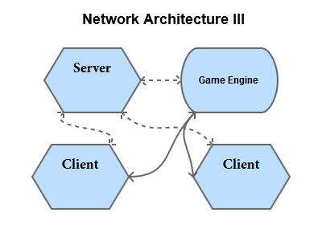

## Client Module Logic

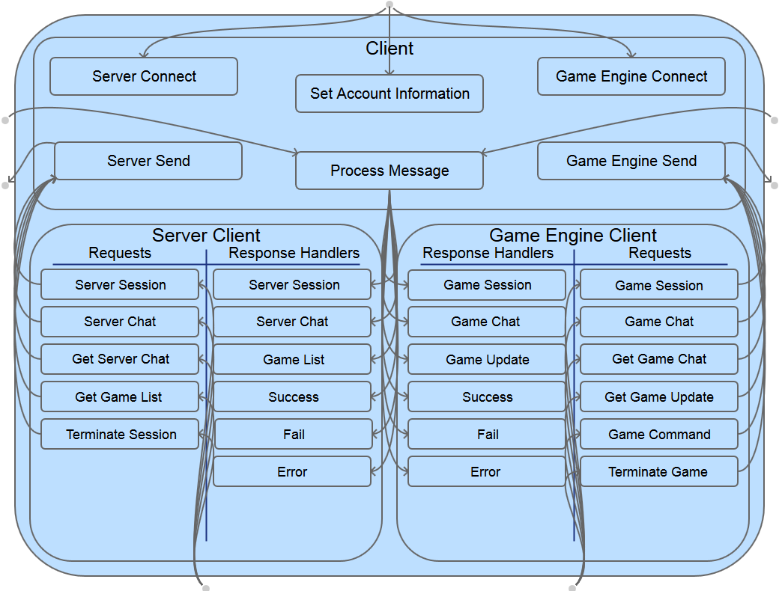

## Server Module Logic

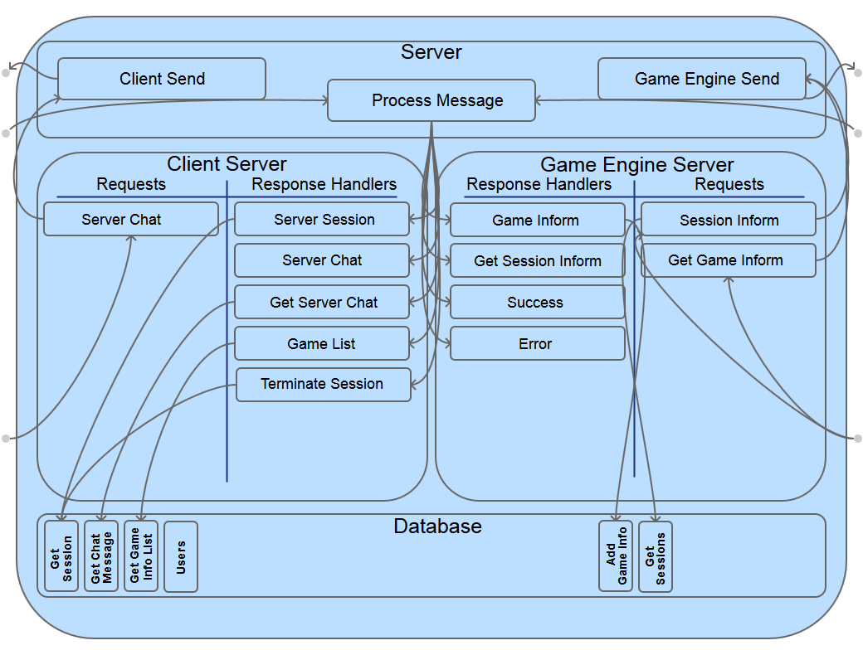

## Game Engine Module Logic

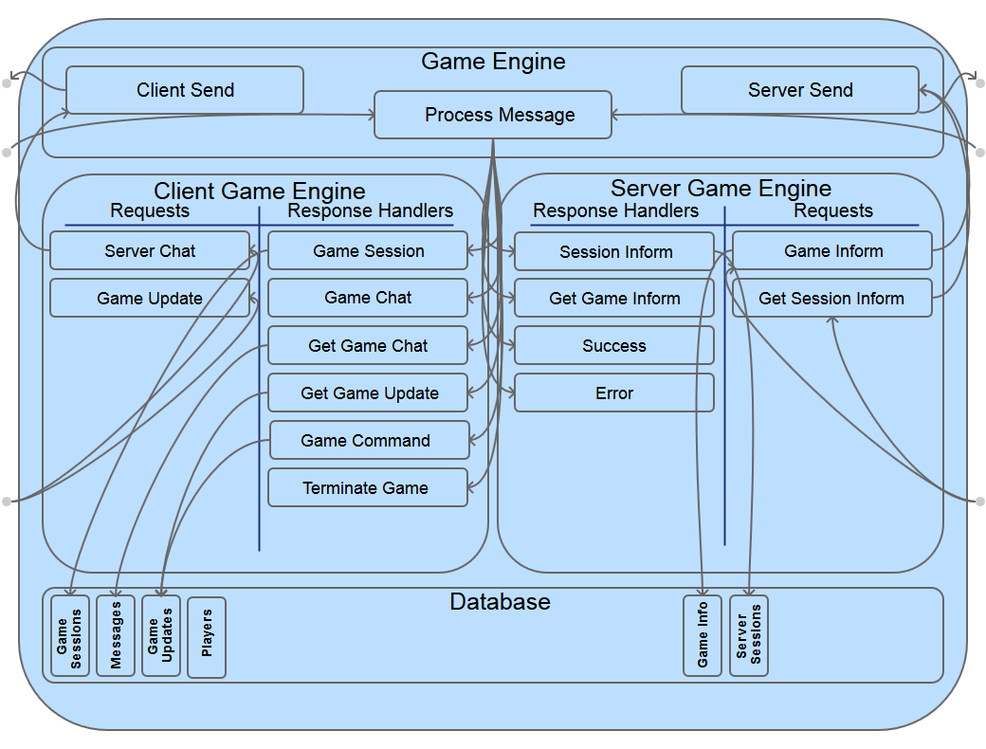

## Client-Server Dialogue

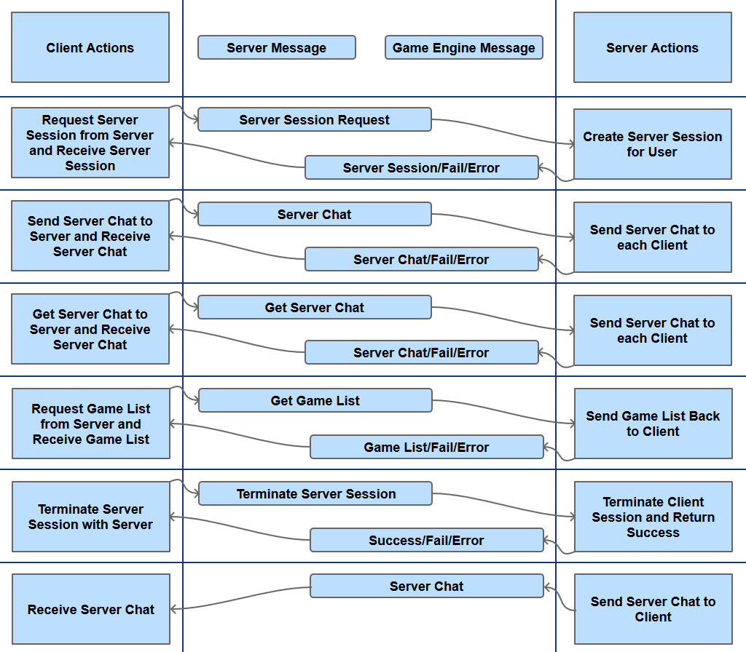

## Client-Game Engine Dialogue

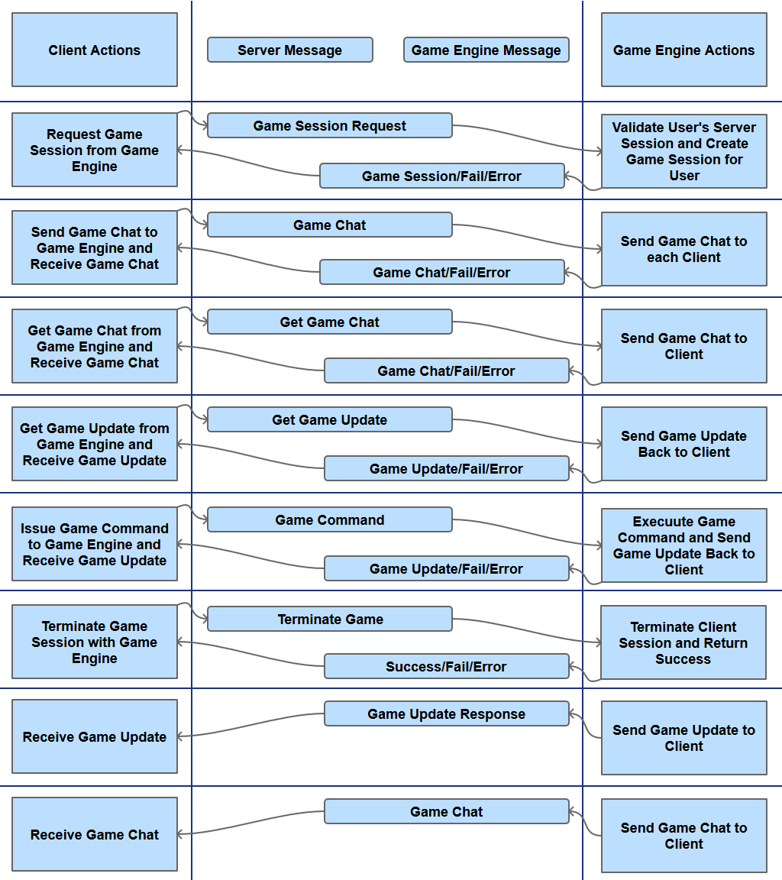

## Client-Server Dialogue

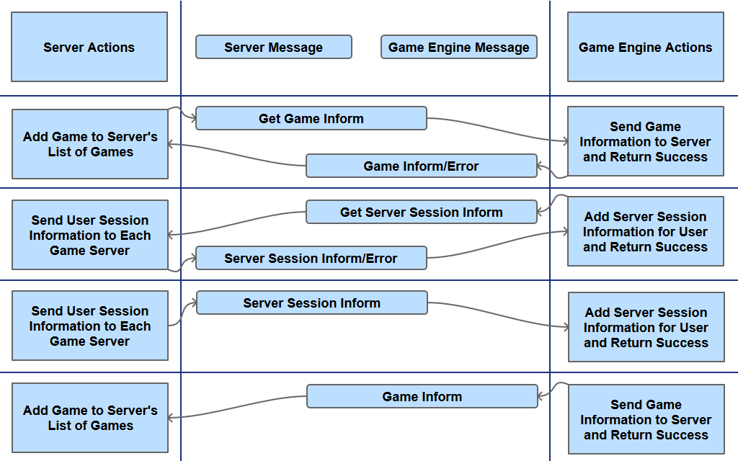

# Discussion of Implementation

## The Server

* Server protocol implemented
* Server protocol tested
* Server protocol fully functional
* Server database implemented
* Server database tested
* Server database fully functional

## Game Engine

* Game Engine protocol implemented
* Game Engine protocol tested
* Game Engine protocol fully functional
* Game Engine database implemented

## Desktop Client

* Client protocol implemented
* Client protocol tested
* Client protocol fully functional

## Web Client

* Client protocol implemented
* Client protocol tested
* Client protocol fully functional

## Prototype

* Early Prototype Requirements Defined

# Problems Encountered

## The Server

Database

* Extra information added to documents
* Documents are not unique by default

Networking

* HTTPClient
  + WebLib HTTPClient - Poor Documentation
  + Tornado HTTPClient - Poor Documentation
  + Unclear if the body is text vs dictionary
* Network Protocol Integration
  + Integrating HTTP and WebSockets - Poor Documentation
  + Integrating WebSockets and TCP Sockets - Poor Documentation
  + Integrating TCP Sockets and HTTP - Poor Documentation

## Game Engine

Database

* Extra information added to documents
* Documents are not unique by default

Networking

* HTTPClient
  + WebLib HTTPClient - Poor Documentation
  + Tornado HTTPClient - Poor Documentation
  + Unclear if the body is text vs dictionary
* Network Protocol Integration
  + Integrating HTTP and WebSockets - Poor Documentation
  + Integrating WebSockets and TCP Sockets - Poor Documentation
  + Integrating TCP Sockets and HTTP - Poor Documentation

## Desktop Client

Networking

* Defining all messages in the protocol
* Polling server for chat messages
* Polling game engine for chat messages

## Web Client

Networking

* Defining all messages in the protocol

## Prototype

Implementation

* Inadequate time to begin or complete

# What was Learned?

## The Server

* Tornado
  + IOLoop
  + HTTP Requests/Responses
  + Web Socket
* Protocol Design

## Game Engine

* Tornado
  + IOLoop
  + HTTP Requests/Responses
  + Web Socket
* Protocol Design

## Desktop Client

* Tornado
  + IOLoop
  + HTTP Requests/Responses
  + Web Socket
* Protocol Design

## Web Client

* C# HTTP Requests/Responses
* Protocol Design

# Future Work

## The Server

### Python Game Engine

* Refactor
* Test

### Networking

* TCP Sockets
* SMS

## Game Engines

### Python Game Engine

* Refactor
* Test
* Fix database issues

### Networking

* TCP Sockets
* SMS

### C# Game Engine

* Implement

### Java Game Engine

* Implement

### NodeJS Game Engine

* Implement

## Clients

### HTTP Desktop Client

* Optimize chat polling

### HTTP Web Client

* Implement

### Android Native Client

* Implement

### IOS Native Client

* Implement

### Windows Modern Native Client

* Implement

### SMS Client

* Implement

### Game View

* Use native web views to use HTML, CSS, and JavaScript on all clients

### Offline app?

## Prototype Games

### Text-based

* Implement

### 2D tile based game

* Implement

### Space Trader

* Ranking system
* Trading post and market
* Auctions
* Multiplayer/Single player
* Store map graph
* Turn-based gameplay/ Real-time events
* Track player
* Track upgrades

# Appendix I – Original Proposal

Michael Richardson

December 27, 2013

CS 4670

## Project Proposal

### Abstract

The project is to build a multi-platform space-themed game with a modular architecture and elements of gameplay for both entertainment and education. My portion of the project is to define requirements, design, build and test a server to run on a Linux machine and clients to run on various platforms including web and mobile to play the space game. I will be implementing an early prototype of the game to test the clients and server.

### Detailed Description

This is a long-term project spanning multiple semesters with a modular architecture so students can work on modules independently or as part of a research group. The game will have a space theme and will incorporate aspects of role-playing, strategy, and 4x games (explore, expand, exploit, and exterminate).

My portion of the project is to define requirements, design, build and test libraries for clients and a server with a database for players, characters, and world (setting) information. The server will be written in python and will need to support HTTP traffic as well as sockets and web sockets. The database will store data as JSON objects in MongoDB. The API for the server will adhere to principles of HATEOAS and REST. I will be creating a central server program with libraries for database, communication and game logic.

The communication libraries will be built to support socket connections, JSON traffic and elements of the API and protocol(s). The protocol will include definitions of the types of data and their properties. TCP socket connections for both HTTP and real-time traffic. Players will be able to use a variety of clients including: desktop applications, native mobile applications, desktop and mobile browsers and SMS. These clients may use 3D graphics, 2D graphics, ASCII Graphics or just text, depending on the type of client and available network bandwidth. Some parts of the game will not be accessible every client (SMS being particularly limited).

I will develop a desktop client for Windows, one or more mobile clients and a web (browser) client. The desktop client will be using Visual Studio 2013 to build either be a console application or a WPF application. The mobile client will be will be built for Windows Modern, Windows Phone or Android. The browser client will be built to be compatible with all major desktop browsers (Chrome, Safari, Firefox and Internet Explorer).

The early prototype of the space-themed game will allow players to move around a map, collect items, achieve some victory condition and communicate real-time with other players. The objective of the server and client is to demonstrate the functionality of the libraries and protocol. Git will provide version control for all the project source code and documentation. The Source code will be released as open source under the Apache License.

### Applicable Tools, Platforms and Standards

* Server
  + Linux
  + Sublime Text
  + Python
  + MongoDB
* Clients
  + Android*
    - Eclipse **or** IntelliJ
    - Java
    - Phone
    - Tablet
  + Windows Metro/Modern
    - Visual Studio 2013
    - C# **or** JavaScript
    - XAML **or** HTML and CSS
  + Web
    - Chrome
    - Firefox
    - Safari
    - Internet Explorer
    - JavaScript
    - HTML
    - CSS
    - Intel XDK
  + Windows Application
    - Console App
    - WPF App
    - Visual Studio 2013
    - C#
    - XAML
* Other
  + NotePad++
  + REST
  + JSON
  + HATEOAS

### Licensing

The source code will be licensed under the Apache License, Version 2.0 as follows:

Copyright 2014 Michael Richardson

Licensed under the Apache License, Version 2.0 (the "License");

you may not use this file except in compliance with the License.

You may obtain a copy of the License at

http://www.apache.org/licenses/LICENSE-2.0

Unless required by applicable law or agreed to in writing, software

distributed under the License is distributed on an "AS IS" BASIS,

WITHOUT WARRANTIES OR CONDITIONS OF ANY KIND, either express or implied.

See the License for the specific language governing permissions and

limitations under the License.

### Proposed Deliverables

1. Source Code (GIT Repository)
2. Communication Libraries and Documentation (Finished and Polished)
3. Multi-platform game (Prototype)
4. Mobile Client (Prototype)
5. Web Client (Prototype)
6. Desktop Client (Prototype)
7. Server (Prototype)
8. Final Project Report
9. Oral Presentation
10. Daily Journal/Work Log
11. Any other relevant items

### Project Schedule

January 6 – Classes Begin

January 13 – Gather and define requirements

January 20 – Design game and API

January 27 – Build Server communication library

February 3 – Build Server communication library

February 10 – Build Client communication libraries

February 17 – Build Client communication libraries

February 24 – Build Client communication libraries

March 3 – Build Client communication libraries

March 10 – Implement database

March 17 – Implement game prototype

March 24 – Implement game prototype

March 31 – Testing

April 7 – Prepare final report and presentation

April 14 – Prepare final report and presentation

April 21 – Prepare final report and presentation

April 25 – Classes end

### Project Details

**Advisor:** Brian Durney

**Completion Semester:** Spring 2014

# Appendix II – Work Log

CS 4670 – Work Log

Contents

January 6, 2014 44

Space Trader 44

Overview 44

Features 44

Overview 45

Features 45

Endless Space 46

Overview 46

January 7, 2014 46

Dwarf Fortress 47

Overview 47

Meeting with Professor Durney 47

January 8, 2014 47

January 9, 2014 47

January 14, 2014 47

January 15, 2014 47

January 20, 2014 47

January 27, 2014 47

February 5, 2014 47

February 7, 2014 47

February 8, 2014 48

February 12, 2014 48

February 14, 2014 48

February 19, 2014 48

February 20, 2014 48

February 27, 2014 48

March 6, 2014 48

March 13, 2014 48

March 16, 2014 49

March 17, 2014 49

March 20, 2014 49

March 24, 2014 49

March 31, 2014 49

April 4, 2014 49

April 5, 2014 49

April 8, 2014 49

April 14, 2014 49

April 20, 2014 49

April 21, 2014 49

April 22, 2014 49

April 24, 2014 49

April 25, 2014 50

April 26, 2014 50

April 28, 2014 50

April 29, 2014 50

April 30, 2014 50

May 1, 2014 50

## January 6, 2014

Created git repository on github to host project. Added Apache 2.0 License for project. Added approved project proposal to repository. Investigated potential game styles for space-themed game prototype.

### Space Trader

### Overview

Space Trader is a complex game, in which the player's aim is to amass enough money to be able to buy a moon to retire to. The player starts out with a small space ship, armed with one simple laser, and 1000 credits in cash. The safest and easiest way to earn money is to trade goods between neighboring solar systems. If the player chooses the goods to trade wisely, it isn't too difficult to sell them with a profit. There are other ways to get rich, though. You might become a bounty hunter and hunt down pirates. It is also possible to become a pirate yourself and rob honest traders of their cargo. Beware, though: pirating is a way to get rich quickly, but the police force will go after you.

### Features

Some of the features of Space Trader are:

Ten different trade goods are available, two of which are considered to be illegal but can bring great profits.

Ten different ship types are available, some of which are especially suitable for trading, some for pirating, and others for both. Ships differ in size, the distance they can travel, their hull strength, the number of weapons, shields and gadgets they can carry, the number of cargo bays and the number of crew quarters that are available.

Ships can be equipped with different selections of equipment, among which are several types of lasers, several types of shields, an escape pod and certain special gadgets like a cloaking device.

You can distribute skill points over your character at the start of the game, to allow you to function well in your chosen role. For the skills your character lacks, mercenaries can be hired which may have different skills.

There are more than a hundred solar systems in the galaxy, with different sizes, tech levels, governments, resources and special situations. These are not just for background color, but play a vital role in the game.

While travelling to another solar system, you might encounter police ships, pirates and other traders. There are several ways to handle such encounters. You can even force a trader to allow you to plunder his ship.

There are about a dozen unique missions and offers available, some of which may bring great special rewards.

There is support for color, grayscale and black&white Palms, with OS version 2.0 and higher. OS 5.0 is supported.

The ships are displayed graphically during an encounter. There are also large pictures during key moments of the game.

Summary retrieved from <http://ticc.uvt.nl/~pspronck/spacetrader/STFrames.html>

<http://en.wikipedia.org/wiki/Space_Trader_(Palm_OS)>

### Sid Meier's Pirates!

#### Overview

Pirates! is a single-player, open world game. The player receives a letter of marque authorizing service as a privateer for the Spanish Empire, the Dutch Republic, the Kingdom of England, or the French colonial empire in the Caribbean. The player's loyalties may change over the course of the game; he may also hold rank with multiple countries and may turn to piracy at any time. Gameplay is open-ended; the player may choose to attack enemy ships or towns, hunt pirates, seek buried treasure, rescue long-lost family members, or even avoid violence altogether and seek to increase his wealth through trade. The game also has no predetermined end, although as time goes on, it becomes more difficult to recruit crew members. As the player character ages, fighting becomes more difficult, and deteriorating health will eventually force the character into retirement. The game ends when the player retires, at which point he is given a position in his future life, from beggar to King's adviser, based on accumulated wealth, land, rank, marital status, and other accomplishments.

#### Features

Some of the features of Pirates! are:

The era of play is one of the choices given to a player at game-start. Different eras provide a different challenge, as political and economic power shifts between the four fledgling European empires.

Ship designs are also era-dependent, with some types of ships appearing more frequently in certain eras and less in others, and certain ship types being used near-exclusively by certain nations.

The game tests a wide range of skills:

hand-eye coordination during the fencing sections

tactical ability during the land and sea combat phases

strategic thinking, for everything from choosing a wife to deciding when to divide up the plunder.

Moreover, each game is likely to take a different course, as most events in the game are random, including the economic and political systems, and early in the game these can greatly affect future strategic options

In Pirates!, many of the most important factors which affect player decisions are randomized at the beginning of the game, and continue to shift during gameplay.

Changes happen whenever time passes and they are unrelated to player actions. In fact, in this game in the series, random events do not have any graphical representation, and the player can do nothing to prevent them.

Relations may differ greatly from game to game, and can shift in an instant, creating and removing opportunities, possibly even for long periods of time

Cities are also dynamic, with statistics like wealth and population fluctuating constantly. The player has a list of cities in one of the game's menus, allowing him to see the statistics of any city. Knowing the statistics of a city helps the player plan ahead, especially with regards to trading or any desire to raid or conquer cities.

Summary retrieved from <http://en.wikipedia.org/wiki/Sid_Meier's_Pirates!>

<http://sidmeierspirates.wikia.com/wiki/Sid_Meier%27s_Pirates!_Wiki>

### Endless Space

#### Overview

Endless Space is a turn-based strategy game set in 3000 AD, where each player (up to a maximum of eight per game) represents the leader of one of nine unique interstellar empires. A player may also choose to create their own unique civilization by selecting from a number of different traits that correspond to military, science, diplomacy, hero units and so on. Each player is to guide their empire over hundreds, if not thousands, of years to diplomatic, scientific, or military conquest, attempting to meet requirements for several different victory conditions. The game takes place in a randomly generated galaxy, which can change in size and shape, depending on how the host player chooses to generate it. Every player begins with one colonised capital system which is connected to further systems via cosmic links, which act as travel routes for starships. Players can also research new technologies from four different research trees, representing military, science, expansion/exploration and diplomacy. Research unlocks new ship types, planetary improvements, stat modifiers (either for heroes or planets), new travel methods which do not rely on cosmic links and more. As players expand their empire, they will gain access to strategic and luxury resources, which can be used to upgrade ships, build improvements and trade with other players. Strategic resources are primarily used to upgrade components of your empire, while luxury resources are primarily used for trade and maintaining your empire's approval rating.

The game uses four basic resources to manage its economy: food, industry, dust and science, or FIDS. Dust is a substance that was leftover from an extremely powerful, ancient, extinct civilization only known as the Endless. Players must balance FIDS in order to rapidly expand their empire, build ships and research advanced technologies. In addition, a lower or imbalanced FIDS across your empire results in a low approval rating. A high approval rating provides bonuses to production efficiency, while a low approval rating can drastically lower efficiency making it incredibly difficult to advance. A tax rate slider can also be adjusted to change approval rating, but lower taxes result in a lower revenue stream of Dust. Hero units can be recruited using the game's currency, Dust, to act as either fleet commanders or system administrators. Each hero unit is unique and provides two unique bonuses, which can be further leveled up. Three hero units are randomly selected from a pool unique to each empire and new hero units are available for purchase every fifty turns.

## January 7, 2014

Reviewed Dwarf Fortress and met with Professor Durney.

### Dwarf Fortress

#### Overview

Every game in Dwarf Fortress starts with the generation of a new world; only one game at a time can be ongoing per world. The exact qualities of a world are randomly generated, but can be influenced quite heavily with input from the player, who determines the map size, natural savagery, mineral occurrence, et cetera. The world generator first uses a fractal algorithm to create a randomized elevation map. This is then further elaborated upon by a temperature map, rainfall projection map, drainage value, vegetation value, and salinity. Each tract of land is then differentiated into a biome based upon a combination of these values. Tracts of land are then sorted into evil, neutral, or good regions, as well as benign, wild, or savage ones. Mountains are then worn away with temporary rivers, followed by permanent ones flowing from high points to low ones. Local animal and plant populations are established, followed by sentient populations.

### Meeting with Professor Durney

Define four or five different games for network architecture to support. These may include SpaceTrader, Risk, Battleship, StarCraft, and others. Choose one game to implement. Design several different network architectures that support these particular games.

## January 8, 2014

Researched network architectures and created diagrams of possible network architectures.

## January 9, 2014

Started defining requirements.

## January 14, 2014

Continued defining requirements.

## January 15, 2014

Continued defining requirements.

## January 20, 2014

API design

## January 27, 2014

Game Design

## February 5, 2014

Researched Python networking and websockets

Implemented websocket chat server

## February 7, 2014

Installed pypi and Tornado

## February 8, 2014

Built simple echo server in tornado. Debugged networking issues in HTTP with Fiddler

Implemented protocol for server

## February 12, 2014

Implemented protocol for game engine

## February 14, 2014

Met with professor Durney and migrated python development from NotePad++ to PyCharm

## February 19, 2014

Tested every request for server and game engine.

Server and game engine are stubbed out for their logic

Server protocol logic complete.

Game engine protocol logic complete.

## February 20, 2014

Began Windows application.

Researched:

Tasks

Await

Async

HTTPClient

PostAsync

JSON libraries

## February 27, 2014

Completed tentative windows application

Began Web Application

## March 6, 2014

Completed tentative web application

Began major refactoring

## March 13, 2014

Continued major refactoring

## March 16, 2014

Everything broken because I tried to move python functions into classes.

## March 17, 2014

Everything working again, moved python functions out of classes. Began MongoDB work.

## March 20, 2014

Database working

## March 24, 2014

Database designed and implemented

## March 31, 2014

Database refactoring

## April 4, 2014

Began comprehensive refactoring

## April 5, 2014

Continued comprehensive refactoring

## April 8, 2014

Continued comprehensive refactoring

## April 14, 2014

Continued comprehensive refactoring

## April 20, 2014

Communication between game engine and server not working.

## April 21, 2014

Communication working again

## April 22, 2014

Completed basic UI for Windows Client and Web Client.

Completed chat functionality and took screenshots of client displays.

## April 24, 2014

Added Pencil files and first draft presentation and report

Added logic diagrams and got HTTP chat working

## April 25, 2014

Added final draft presentation

Continued work on project report

## April 26, 2014

Continued work on project report

## April 28, 2014

Continued work on project report

## April 29, 2014

Continued work on project report

## April 30, 2014

Continued work on project report

## May 1, 2014

Finalized work on project report

# Appendix III – Requirements

Requirements

Contents

Requirements Summary 17

Modular Architecture 17

Architecture Overview 17

The Server Module **Error! Bookmark not defined.**

Game Engine Modules **Error! Bookmark not defined.**

Client Modules **Error! Bookmark not defined.**

Platform Independence 17

The Server 17

Game Engines 17

Clients 18

Responsive Web Design 18

Game Engine – Server Dialogue **Error! Bookmark not defined.**

Client – Server Dialogue **Error! Bookmark not defined.**

Client – Game Engine Dialogue **Error! Bookmark not defined.**

Network Protocol Independence 18

Network Protocol Overview 18

Ubiquitous data format (JSON) 18

The Server communicates over multiple network protocols 18

Game Engines communicate over multiple network protocols 18

Clients communicate over multiple network protocols 19

Abstraction of Networking and Data Storage 19

The Server 19

Game Engines 19

Clients 19

Communication Process 19

Excellent Documentation 19

Motivation 19

Deliverables 20

Potential Games 20

Chess 20

Risk 20

StarCraft 20

SpaceTrader 20

Game Prototype 20

Prototype Details 20

Prototype Objects 21

## Requirements Summary

* Modular Architecture
* Platform Independence
* Network Protocol Independence
* Abstraction of Networking and Data Storage
* Excellent Documentation
* Potential Games
* Game Prototype

## Modular Architecture

### Architecture Overview

* The Server Module
  + Connects Clients and Game Engines
  + Manages Client Identification
  + Manages User Authentication
  + Provides “Global” Chat
* Game Engine Modules
  + Store game resources
  + Coordinates clients.
  + Executes game logic
  + Issues game updates
  + Provides “Local” Chat
* Client Modules
  + Issues game commands
  + Displays game updates
  + Uses “Global” Chat
  + Uses “Local” Chat



Figure - Network Architecture

### The Server Module



Figure - Server Module Logic

### Game Engine Modules



Figure - Game Engine Module Logic

### Client Modules



Figure - Client Module Logic

## Platform Independence

### The Server

* Runs anywhere using Python
* Stores data in the ubiquitous format JSON

### Game Engines

* Runs anywhere using Python
* May be written in any language for any platform
* Stores data in the ubiquitous format JSON

### Clients

* May be written in any language for any platform
* Websocket web client can run in any modern web browser
* HTTP web client can run in any web browser
* Utilizes “Responsive Web Design” for an optimal viewing experience on any display

### Responsive Web Design

“Fluid grids, flexible images, and media queries are the three technical ingredients for responsive web design, but it also requires a different way of thinking.” Responsive web design requires thinking about the design of a web site holistically, preserving the conceptual integrity of the site while providing optimal presentation across a variety of viewing experiences.”

*Marcotte, Ethan. 2010. Responsive web design. In A list apart*

### Game Engine – Server Dialogue



Figure - Game Engine - Server Dialogue

### Client – Server Dialogue



Figure - Client - Server Dialogue

### Client – Game Engine Dialogue



Figure - Client - Game Engine Dialogue

## Network Protocol Independence

### Network Protocol Overview

* Ubiquitous data format (JSON)
* The Server communicates over multiple network protocols
* Game Engines communicate over multiple network protocols
* Clients communicate over multiple network protocols

### Ubiquitous data format (JSON)

* JSON (JavaScript Object Notation)
* Lightweight format
  + {}
  + []
  + “a”: “b”
  + “c”: 0
* Simple and powerful format
  + Values
  + Objects
  + Arrays
* Parsers are easily available for nearly every language and platform

### The Server communicates over multiple network protocols

* Must communicate over HTTP
* Must communicate over WebSockets

### Game Engines communicate over multiple network protocols

* May communicate over HTTP
* May communicate over WebSockets

### Clients communicate over multiple network protocols

* May communicate over HTTP
* May communicate over WebSockets

## Abstraction of Networking and Data Storage

### The Server

* Provides “Global” Server Chat

### Game Engines

* Process Game Update Requests
* Process Game Commands
* Issue Game Updates
* Provides “Local” Game Chat
* Game engines may act as clients to communicate with other Game Engines

### Clients

* Get Game Updates
* Process Game Updates
* Issue Game Commands
* “Global” Server Chat
* “Local” Game Chat

### Communication Process

1. Game engine registers IP address, port, game name and game parameters with server.
2. Client requests server session
3. Server responds with session
4. Server sends session information to game engines
5. Client requests game information from server
6. Server returns game information to client
7. Client establishes connection to game engine
8. Client and game engine communicate until game completion
   * Game Updates
   * Game Commands
9. Connection is terminated and client idles until repeating the process

## Excellent Documentation

## Motivation

The Role of Software Documentation:

* To facilitate program comprehension
* To act as a guide to the user
* To complement the system

*Penny Grubb and Armstrong Takang. Software Maintenance: Concepts and Practice*

## Deliverables

* JSON Objects Documentation
* JSON Messages Documentation
* Module Logic Diagrams
* Protocol Dialogue Diagrams

## Potential Games

### Chess

* Two players
* Turn-based
* Track pieces

### Risk

* Up to six players
* Turn-based
* Store Map
* Track units
* Track bonuses

### StarCraft

* Up to eight players
* Store map, exploration, and visibility
* Real-time
* Track units
* Track score

### SpaceTrader

* Multiplayer/Single player
* Store map graph
* Turn-based / Real-time
* Player trading
* Track player
* Track upgrades

## Game Prototype

### Prototype Details

* Support for player trading and chat
* Support for NPC encounters (trading/pirates)
* Minimum of 4 spaceports
* Minimum of 9 paths
* Support for buying and selling Commodities
* Support for upgrading and downgrading ships

### Prototype Objects

* Character
  + Credits
  + Skills
* NPC Pirate
  + Ransom Cost
* NPC Trader
  + Barter Rate
* Ship
  + Weapons
  + Shields
  + Traveling Range
  + Capacity
  + Commodities
* Path
  + Source
  + Target
  + Distance
* Spaceport
  + Barter Rate
  + Commodities
  + Ships
  + Paths out
* Commodity
  + Name
  + Value
* SpaceMap

# Appendix IV – JSON Messages

JSON Messages

Server – Game Engine **Error! Bookmark not defined.**

Server Session Inform (Server to Game Engine) **Error! Bookmark not defined.**

Get Session Inform (Game Engine to Server) **Error! Bookmark not defined.**

Game Inform (Game Engine to Server) **Error! Bookmark not defined.**

Get Game Inform (Server to Game Engine) **Error! Bookmark not defined.**

Success (Game Engine to Server) **Error! Bookmark not defined.**

Error (Game Engine to Server) **Error! Bookmark not defined.**

Success (Server to Game Engine) **Error! Bookmark not defined.**

Error (Server to Game Engine) **Error! Bookmark not defined.**

Client – Game Engine **Error! Bookmark not defined.**

Game Session Request (Client to Game Engine) **Error! Bookmark not defined.**

Game Session (Game Engine to Client) **Error! Bookmark not defined.**

Game Chat Message (Client to Game Engine | Game Engine to Clients) **Error! Bookmark not defined.**

Get Game Chat Message (Client to Game Engine) **Error! Bookmark not defined.**

Get Game Update (Client to Game Engine) **Error! Bookmark not defined.**

Game Update (Game Engine to Client) **Error! Bookmark not defined.**

Game Command (Client to Game Engine) **Error! Bookmark not defined.**

Terminate Game (Client to Game Engine) **Error! Bookmark not defined.**

Success (Game Engine to Client and Server) **Error! Bookmark not defined.**

Fail (Game Engine to Client and Server) **Error! Bookmark not defined.**

Error (Game Engine to Client and Server) **Error! Bookmark not defined.**

Client – Server **Error! Bookmark not defined.**

Server Session Request (Client to Server) **Error! Bookmark not defined.**

Server Session (Server to Client) **Error! Bookmark not defined.**

Server Chat Message (Client to Server | Server to Clients) **Error! Bookmark not defined.**

Get Server Chat Message (Client to Server) **Error! Bookmark not defined.**

Get Game List (Client to Server) **Error! Bookmark not defined.**

Game List (Server to Client) **Error! Bookmark not defined.**

Terminate Session (Client to Server) **Error! Bookmark not defined.**

Success (Server to Client and Game Engine) **Error! Bookmark not defined.**

Fail (Server to Client and Game Engine) **Error! Bookmark not defined.**

Error (Server to Client and Game Engine) **Error! Bookmark not defined.**

## Server – Game Engine

### Server Session Inform (Server to Game Engine)

|  |
| --- |
| {  "Type": "Session Inform",  "Sessions": {},  "Source": "Server"  } |

### Get Session Inform (Game Engine to Server)

|  |
| --- |
| {  "Type": "Get Session Inform",  "Source": "Game Engine"  } |

### Game Inform (Game Engine to Server)

|  |
| --- |
| {  "Type": "Game Inform",  "Ip": "127.0.0.1",  "Port": 6500,  "GameInfo": {  "Title": "Game 1",  "Network": {  "IP Address": "127.0.0.1",  "URL": "localhost",  "Port": 6500,  "Communication": "HTTP",  },  "Parameters": {  "Minimum Players": 2,  "Maximum Players": 8,  "Current Players": 4  },  },  "Source": "Game Engine"  } |

### Get Game Inform (Server to Game Engine)

|  |
| --- |
| {  "Type": "Get Game Inform",  "Source": "Server"  } |

### Success (Game Engine to Server)

|  |
| --- |
| {  "Type": "Success",  "Command": "",  " Message ": "",  "Source": "Game Engine"  } |

### Error (Game Engine to Server)

|  |
| --- |
| {  "Type": "Error",  "Command": "",  "Message": "",  "Source": "Game Engine"  } |

### Success (Server to Game Engine)

|  |
| --- |
| {  "Type": "Success",  "Command": "request type",  " Message ": "",  "Source": "Server"  } |

### Error (Server to Game Engine)

|  |
| --- |
| {  "Type": "Error",  "Command": "Chat",  "Message": "",  "Source": "Server"  } |

## Client – Game Engine

### Game Session Request (Client to Game Engine)

|  |
| --- |
| {  "Type": "Game Session Request",  "Username": "user",  "SessionNumber": 123,  "Source": "Client"  } |

### Game Session (Game Engine to Client)

|  |
| --- |
| {  "Type": "Game Session",  "SessionNumber": 123,  "PlayerName": "player",  "Player": {  "Name": "player",  "History": []  },  "Source": "Game Engine"  } |

### Game Chat Message (Client to Game Engine | Game Engine to Clients)

|  |
| --- |
| {  "Type": "Game Chat",  "SessionNumber": 123,  "PlayerName": "player",  "Message": "user message",  "Status": "active",  "Source": "Client"  } |

### Get Game Chat Message (Client to Game Engine)

|  |
| --- |
| {  "Type": "Get Game Chat",  "SessionNumber": 123,  "PlayerName": "player",  "Source": "Client"  } |

### Get Game Update (Client to Game Engine)

|  |
| --- |
| {  "Type": "Get Game Update",  "SessionNumber": 123,  "PlayerName": "player",  "Source": "Client"  } |

### Game Update (Game Engine to Client)

|  |
| --- |
| "Game Update":{  "SessionNumber": 123,  "PlayerName": "player",  "Update": {},  "Source": "Game Engine"  } |

### Game Command (Client to Game Engine)

|  |
| --- |
| {  "Type": "Game Command",  "SessionNumber": 123,  "PlayerName": "player",  "Command": {},  "Source": "Client"  } |

### Terminate Game (Client to Game Engine)

|  |
| --- |
| {  "Type": "Terminate Game",  "SessionNumber": 123,  "PlayerName": "player",  "Source": "Client"  } |

### Success (Game Engine to Client and Server)

|  |
| --- |
| {  "SessionNumber": 123,  "PlayerName": "player",  "Type": "Success",  "Command": "request type",  " Message ": "",  "Source": "Game Engine"  } |

### Fail (Game Engine to Client and Server)

|  |
| --- |
| {  "SessionNumber": 123,  "PlayerName": "player",  "Type": "Fail",  "Command": "request type",  " Message ": "",  "Source": "Game Engine"  } |

### Error (Game Engine to Client and Server)

|  |
| --- |
| {  "SessionNumber": 123,  "PlayerName": "player",  "Type": "Error",  "Command": "Chat",  "Message": "",  "Source": "Game Engine"  } |

## Client – Server

### Server Session Request (Client to Server)

|  |
| --- |
| {  "Type": "Server Session Request",  "Username": "user",  "Password": "password hash",  "Source": "Client"  } |

### Server Session (Server to Client)

|  |
| --- |
| {  "Type": "Server Session",  "SessionNumber": 123,  "Username": "user",  "Source": "Server"  } |

### Server Chat Message (Client to Server | Server to Clients)

|  |
| --- |
| {  "Type": "Server Chat",  "SessionNumber": 123,  "Username": "user",  "Message": "user message",  "Status": "active",  "Source": "Client"  } |

### Get Server Chat Message (Client to Server)

|  |
| --- |
| {  "Type": "Get Server Chat",  "SessionNumber": 123,  "Username": "user",  "Source": "Client"  } |

### Get Game List (Client to Server)

|  |
| --- |
| {  "Type": "Get Game List",  "SessionNumber": 123,  "Username": "user",  "Platform": "iPhone",  "Features": [],  "Source": "Client"  } |

### Game List (Server to Client)

|  |
| --- |
| {  "Type": "Game List ",  "SessionNumber": 123,  "Username": "user",  "Games":[  "Game": “Game 1”,  "Game": “Game 2”,  "Game": “Game 3”,  "Game": “Game 4”  ] ,  "Source": "Server"  } |

### Terminate Session (Client to Server)

|  |
| --- |
| {  "Type": "Terminate Session",  "SessionNumber": 123,  "Username": "user",  "Source": "Client"  } |

### Success (Server to Client and Game Engine)

|  |
| --- |
| {  "Type": "Success",  "SessionNumber": 123,  "Username": "user",  "Command": "request type",  " Message ": "",  "Source": "Server"  } |

### Fail (Server to Client and Game Engine)

|  |
| --- |
| {  "Type": "Fail",  "SessionNumber": 123,  "Username": "user",  "Command": "request type",  " Message ": "",  "Source": "Server"  } |

### Error (Server to Client and Game Engine)

|  |
| --- |
| {  "Type": "Error",  "SessionNumber": 123,  "Username": "user",  "Command": "Chat",  "Message": "",  "Source": "Server"  } |

# Appendix V – JSON Objects

JSON Objects

Server 78

Game Engines 78

Game Engine 78

Sever Sessions 78

Server Session 78

Users 78

User 78

Game Information List 78

Game Information 79

Server Chat Messages 80

Server Chat Message 81

Game Engine 82

Sever Sessions 82

Server Session 82

Game Sessions 82

Game Session 82

Players 82

Player 83

Game 83

Game Updates 83

Game Update 83

Game Information 83

Game Chat Messages 84

Game Chat Message 84

Client 85

Game Command 85

## Server

### Game Engines

|  |
| --- |
| {  {"GameEngine": {"Ip": "127.0.0.1", "Port": 6500}},  {"GameEngine": {"Ip": "127.0.0.1", "Port": 6500}}  } |

### Game Engine

|  |
| --- |
| {"Ip": "127.0.0.1", "Port": 6500} |

### HTTP Clients

|  |
| --- |
| {  {"HTTPClient": {"Ip": "127.0.0.1", "Port": 6500}},  {"HTTPClient": {"Ip": "127.0.0.1", "Port": 6500}}  } |

### HTTP Client

|  |
| --- |
| {"Ip": "127.0.0.1", "Port": 6500} |

### Sever Sessions

|  |
| --- |
| {  {"Session": {"SessionNumber": 123, "Username": "user"}, "SessionNumber": 123},  {"Session": {"SessionNumber": 123, "Username": "user"}, "SessionNumber": 123}  } |

### Server Session

|  |
| --- |
| {"SessionNumber": 123, "Username": "user"} |

### Users

|  |
| --- |
| {  {"User": {"Username": "user", "Password": "password"}, "Username": "user"},  {"User": {"Username": "user", "Password": "password"}, "Username": "user"}  } |

### User

|  |
| --- |
| {"Username": "user", "Password": "password"} |

### Game Information List

|  |
| --- |
| {  {  "Title": "Game 1",  "GameInformation":  {  "Title": "Game 1",  "Network":  {  "Ip": "127.0.0.1",  "URL": "localhost",  "Port": 6500,  "Communication": "HTTP",  },  "Parameters":  {  "Minimum Players": 2,  "Maximum Players": 8,  "Current Players": 4  }  }  },  {  "Title": "Game 1",  " GameInformation ":  {  "Title": "Game 2",  "Network":  {  "Ip": "127.0.0.1",  "URL": "localhost",  "Port": 6500,  "Communication": "HTTP",  },  "Parameters":  {  "Minimum Players": 2,  "Maximum Players": 8,  "Current Players": 4  }  }  }  } |

### Game Information

|  |
| --- |
| {  "Title": "Game 2",  "Network":  {  "IP Address": "127.0.0.1",  "URL": "localhost",  "Port": 6500,  "Communication": "HTTP",  },  "Parameters":  {  "Minimum Players": 2,  "Maximum Players": 8,  "Current Players": 4  }  } |

### Server Chat Messages

|  |
| --- |
| {  {  "SessionNumber": 123,  "ChatMessage":  {  "Type": "Server Chat",  "SessionNumber": 123,  "Username": "user",  "Message": "user message",  "Status": "active",  "Source": "Server"  }  },  {  "SessionNumber": 123,  "ChatMessage":  {  "Type": "Server Chat",  "SessionNumber": 123,  "Username": "user",  "Message": "user message",  "Status": "active",  "Source": "Server"  }  }  } |

### Server Chat Message

|  |
| --- |
| {  "Type": "Server Chat",  "SessionNumber": 123,  "Username": "user",  "Message": "user message",  "Status": "active",  "Source": "Server"  } |

## Game Engine

### HTTP Clients

|  |
| --- |
| {  {"HTTPClient": {"Ip": "127.0.0.1", "Port": 6500}},  {"HTTPClient": {"Ip": "127.0.0.1", "Port": 6500}}  } |

### HTTP Client

|  |
| --- |
| {"Ip": "127.0.0.1", "Port": 6500} |

### Sever Sessions

|  |
| --- |
| {  {{"SessionNumber": 123, "Username": "user"}, "SessionNumber": 123},  {{"SessionNumber": 123, "Username": "user"}, "SessionNumber": 123}  } |

### Server Session

|  |
| --- |
| {"SessionNumber": 123, "Username": "user"} |

### Game Sessions

|  |
| --- |
| {  {{"SessionNumber": 123, "PlayerName": "player"}, "SessionNumber": 123},  {{"SessionNumber": 123, "PlayerName": "player"}, "SessionNumber": 123}  } |

### Game Session

|  |
| --- |
| {"SessionNumber": 123, "PlayerName": "player"} |

### Players

|  |
| --- |
| {  {  "PlayerName": "player",  "Player":  {  "PlayerName": "player",  . . .  }  },  {  "PlayerName": "player",  "Player":  {  "PlayerName": "player",  . . .  }  }  } |

### Player

|  |
| --- |
| {  "PlayerName": "player",  . . .  } |

### Game

|  |
| --- |
| {  . . .  } |

### Game Updates

|  |
| --- |
| {  {"SessionNumber": 123, "GameUpdate": { . . . }},  {"SessionNumber": 123, "GameUpdate": { . . . }}  } |

### Game Update

|  |
| --- |
| {  . . .  } |

### Game Information

|  |
| --- |
| {  "Title": "Game 1",  "Network":  {  "IP Address": "127.0.0.1",  "URL": "localhost",  "Port": 6500,  "Communication": "HTTP",  },  "Parameters":  {  "Minimum Players": 2,  "Maximum Players": 8,  "Current Players": 4  }  } |

### Game Chat Messages

|  |
| --- |
| {  {  "SessionNumber": 123,  "ChatMessage":  {  "Type": "Game Chat",  "SessionNumber": 123,  "Username": "user",  "Message": "user message",  "Status": "active",  "Source": "Server"  }  },  {  "SessionNumber": 123,  "ChatMessage":  {  "Type": "Game Chat",  "SessionNumber": 123,  "Username": "user",  "Message": "user message",  "Status": "active",  "Source": "Server"  }  }  } |

### Game Chat Message

|  |
| --- |
| {  "Type": "Game Chat",  "SessionNumber": 123,  "Username": "user",  "Message": "user message",  "Status": "active",  "Source": "Server"  } |

## Client

### Game Command

|  |
| --- |
| {  . . .  } |

# Appendix VI – Presentation

Slide 1



Slide 2



Slide 3



Slide 4



Slide 5



Slide 6



Slide 7



Slide 8



Slide 9



Slide 10



Slide 11



Slide 12



Slide 13



Slide 14



Slide 15



Slide 16



Slide 17



Slide 18



Slide 19



Slide 20



Slide 21



Slide 22



Slide 23



Slide 24



Slide 25



Slide 26



Slide 27



Slide 28



Slide 29



Slide 30



Slide 31



Slide 32



Slide 33



Slide 34



Slide 35



Slide 36



Slide 37

